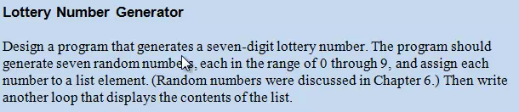

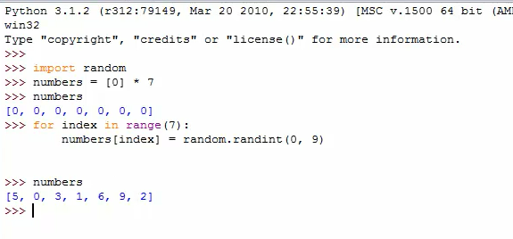
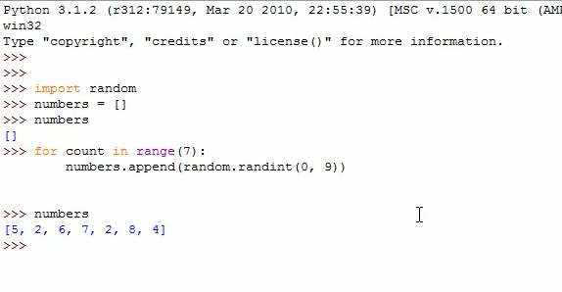
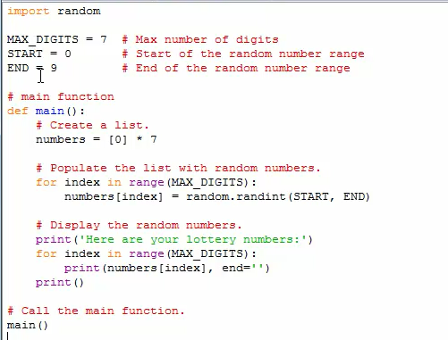

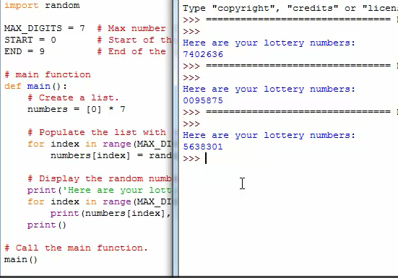
Total Sales Homework
Design a program that asks the user to enter a store’s sales for each day of the week. The amounts should be stored in a list. Use a loop to calculate the total sales for the week and display the result.

